Course Title : Big Data Analytics
Course Code : Z1AMC 702
Name: Krish Shah Registration No: 2511042210018

Experiment 4: Word Count of All Files Using Hadoop MapReduce
1) Objective
To perform a Word Count operation on multiple text files stored in HDFS using the Hadoop MapReduce framework and display the frequency of each word.

2) Procedure
Step 1: Create Input Text Files
Create multiple text files containing sample text data
file1.txt
hadoop is powerful
hadoop is scalable

file2.txt
big data with hadoop
hadoop supports mapreduce

Step 2: Verify the Files
cat file1.txt
cat file2.txt
Output:
-rw-r--r-- 1 krish supergroup 38 2026-06-19 13:15 /input2/file1.txt
-rw-r--r-- 1 krish supergroup 47 2026-06-19 13:15 /input2/file2.txt

Step 3: Create and upload HDFS Input Directory
hdfs dfs -put file1.txt /input2

Step 4: Make output file
hadoop jar $HADOOP_HOME/share/hadoop/mapreduce/hadoop-mapreduce-examples-*.jar wordcount /input2 /output3

Step 5: Run the Word Count Program and View
hdfs dfs -cat /output3/part-r-00000

Output:
big 1
data 1
hadoop 4
is 2
mapreduce 1
powerful 1
scalable 1
supports 1
with 1

3) Source Code
hadoop jar $HADOOP_HOME/share/hadoop/mapreduce/hadoop-mapreduce-examples-*.jar wordcount input output

4) Screen Short
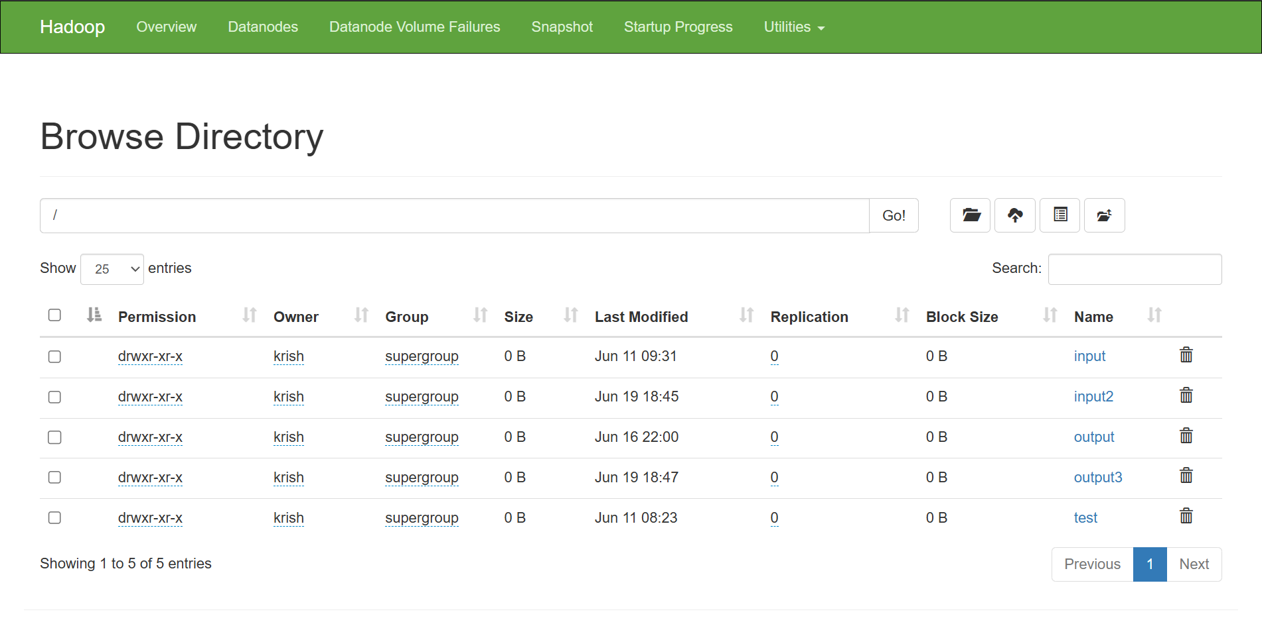

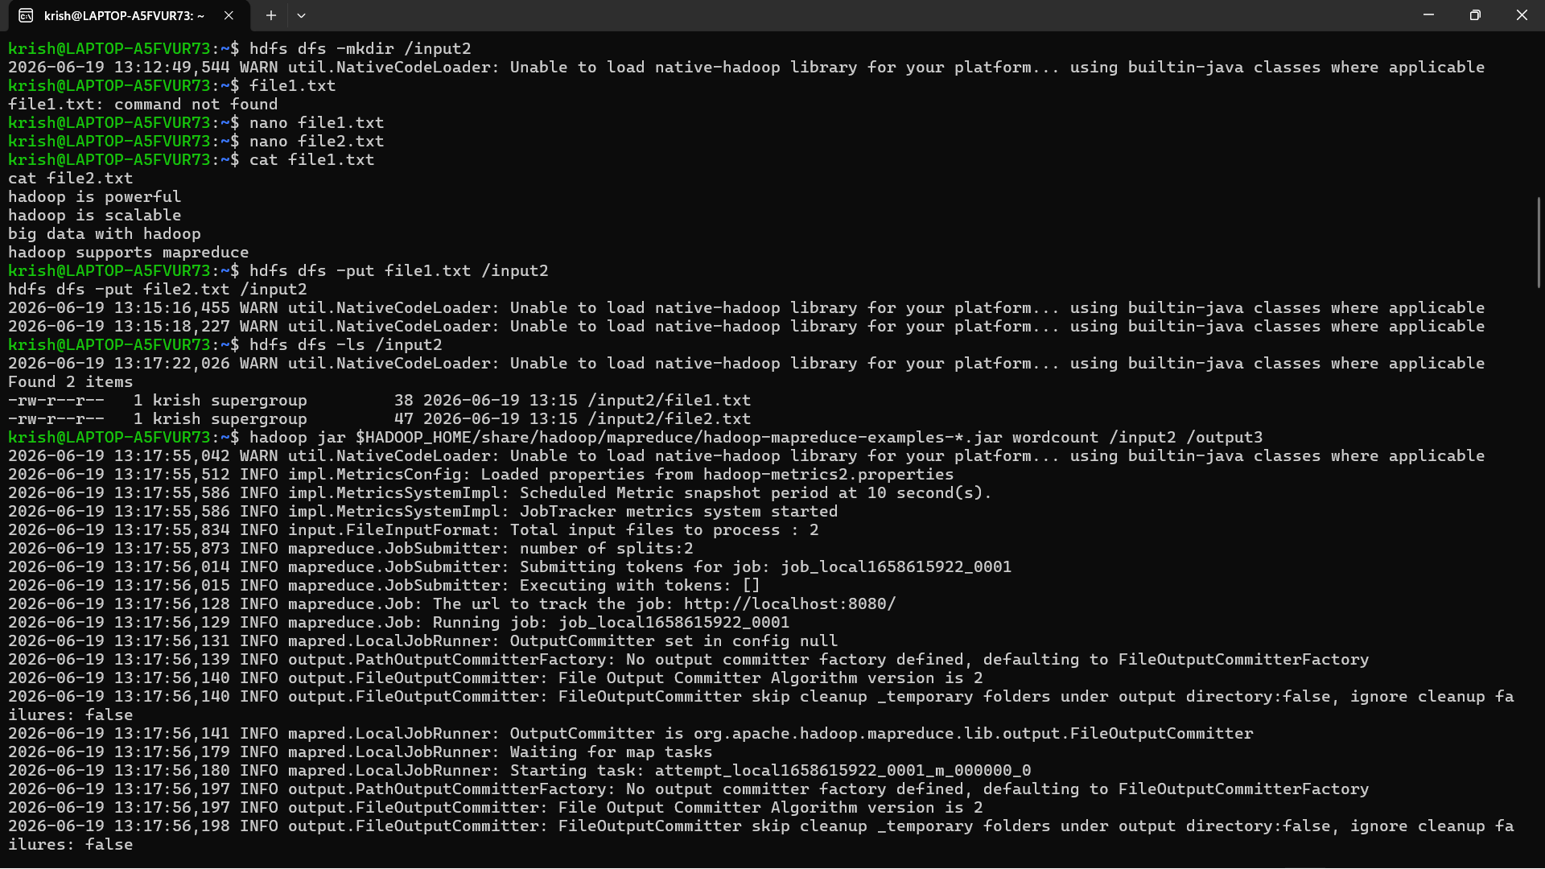
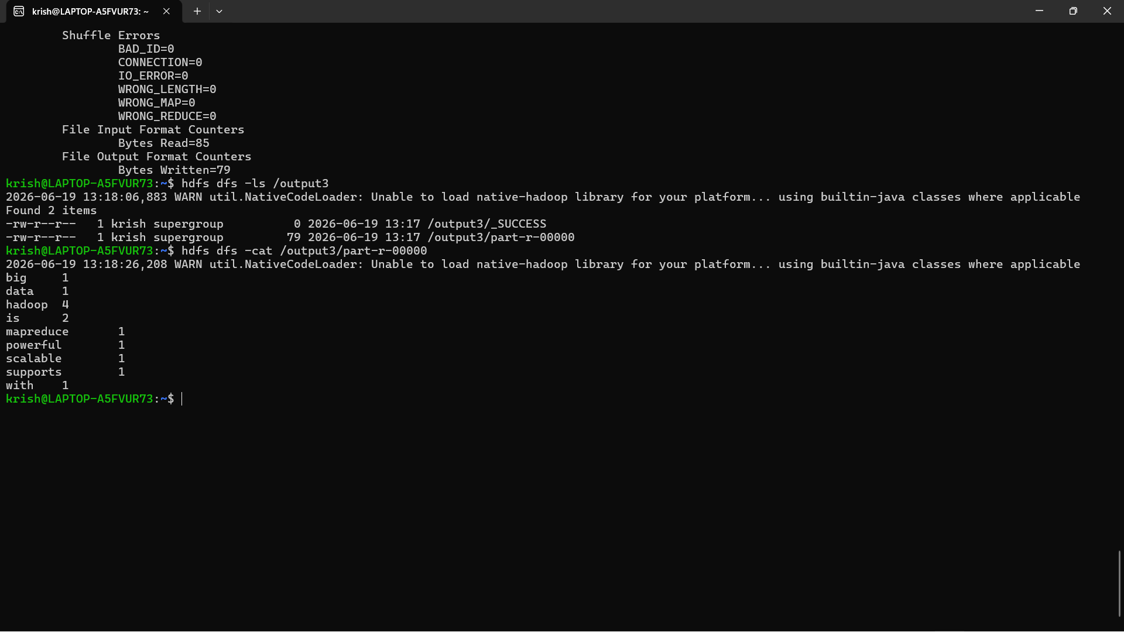
5) Conclusion
The Word Count MapReduce program was successfully executed on multiple text files stored in HDFS. Hadoop processed the files in a distributed manner and generated the frequency count of each word. The experiment demonstrated the working of the Map and Reduce phases and showed how Hadoop can efficiently process large datasets.

